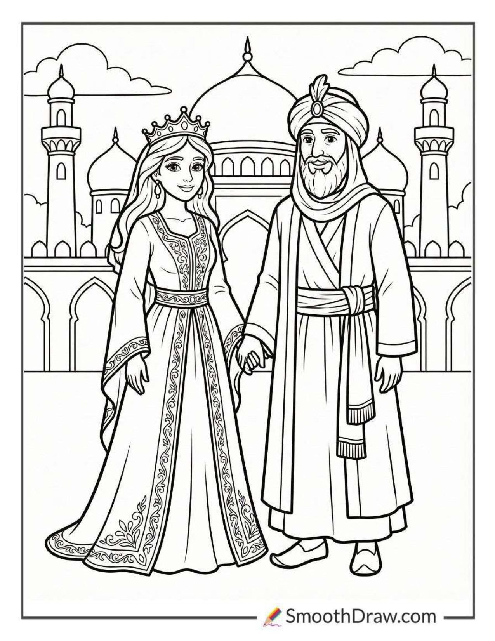

Purim
pg

Reader 12: We will be able to trust that YHWH, who has been faithful time and again to deliver His people, will be faithful to us as well, even if we have not been as faithful to Him as we should have been!
Reader 13: Our trust in YHWH is based on His character and not our own.
Reader 14: When we realize that we have allowed ourselves to fall into compromise and are not living out our identity as children of YHWH and followers of Messiah Yeshua, we can draw a line in the sand like Mordecai, repent, and say “No more.”
Reader 15: And we can stand and boldly proclaim Who we belong to, as Esther did!
Reader 16: Seeing Yah’s faithfulness in the story of Esther and Mordecai inspires us to rededicate ourselves to worshipping YHWH alone and to living set-apart lives of purity and holiness by the power of His Holy Spirit.
Hostess: Let’s close our time together in prayer, and then we can sing some songs of thanksgiving and worship.
Host: YHWH our God, Ruler of the universe, who has chosen us among all peoples and sanctified us with Your love, we praise You! With an everlasting love, You have given us feasts, holidays, and seasons for rejoicing and for remembering Your faithfulness to us.
Hostess: On this Feast of Purim, we celebrate the salvation and the freedom that You have ultimately given us in Yeshua, and we pray that You will strengthen us to remain faithful to You no matter what sorts of persecution come our way.
Host: Give us grace to repent quickly when we see that we have fallen into compromise or disobedience, and may we recognize that You have placed us in our spheres of influence for just such a time as this. Give us courage and strength to stand up for truth and justice for Your glory among the nations. Amen.

Suggested Songs:
For Such a Time as This by Tina Chen
Reversals by Tina Chen
Confidence by Sanctus Real
Battle Belongs by Phil Wickham
You Keep Your Promises by Charity Gayle
My Deliverer by Tina Chen
They Will Be Mine by Tina Chen
Feast of Esther
Page 7
Script text written by Tina Chen © 2026
Purim
Host: Tonight marks an important event in our history as people of Yah, the Feast of Purim, in which we celebrate a time in history that Yah miraculously preserved His people. This event was recorded for us in the book of Esther in our Bibles.
Hostess: Celebrating this Feast of Purim together tonight and recounting how Yah used Queen Esther and her cousin Mordecai to save Persian Jews from wicked Haman's plot links us with the past because it is an ancient tradition that has been handed down from generation to generation.
Reader 1: As a Jew living in the first century, Messiah Yeshua would have celebrated this feast with His family and friends, and by doing the same, we are following His example.
Reader 2: We celebrate together today with the hope that the experience of Yah preserving and delivering His people, purely by His grace and through no merit of their own, will become part of our own personal experience.
Reader 3: The story we recount at Purim took place over 100 years after the Babylonian exile of the southern kingdom of Judah and around 480 years before Messiah Yeshua was born.
Reader 4: It began with Ahasuerus, the king of Persia, throwing ultra-lavish banquets for about six months to show off his wealth and power, but he was humiliated on the final day when his queen, Vashti, refused to be part of his grandiose display.
Reader 5: Following the poor counsel of his advisors, he deposed her and rounded up all the beautiful virgins from his kingdom to choose a new queen.
Reader 6: Esther, also called Hadassah, was one of the virgins who was rounded up.
Reader 7: She was a Jewish orphan, who had been raised by her cousin Mordecai, a Benjamite who could trace his lineage all the way back to Kish, the father of Israel’s King Saul.
Reader 8: When she was taken, Mordecai instructed her not to disclose her people or her relatives.
Reader 9: Esther found favor with the king and was chosen to be the new queen.
Reader 10: Soon after Esther was made queen, Mordecai overheard a plot to assassinate the king and informed Esther about it. She passed it on to the king, giving credit for the information to Mordecai.
Reader 11: The matter was quickly investigated, the conspirators were executed, and the report was entered into the king’s chronicles and then forgotten.
Reader 12: Some time later, a wicked man rose to power as one of the king’s most trusted allies and advisors.
Reader 13: He was Haman, a descendant of Agag, who, during King Saul’s reign of Israel, had been king of the Amalekites, Israel’s ancient enemy dating all the way back to the time of Moses.

Feast of Esther
Host: There are many lessons we can learn from this story of Esther. It is inspiring to see how YHWH placed Mordecai and Esther in very specific roles at very specific times to accomplish His purposes. We can trust that He is doing the same with each of us.
Hostess: Even when we, like Esther and Mordecai, find ourselves in times of chaos and uncertainty, when deception and lies are abounding all around us, and the kingdoms of the world are demanding that we bow in allegiance to them, we can choose, like Esther and Mordecai, to fix our eyes on YHWH, to stand firm in His truth, to humble ourselves before Him with fasting and prayer, and then watch as He works His signature reversals and humiliates the Enemy before our eyes!
Reader 1: From Saul’s ancient part in the story, we can also learn the dangers of small acts of disobedience that feel like they won’t matter in the grand scheme of things.
Reader 2: None of us would want our family’s descendants to find themselves in a situation like Mordecai and Esther’s, where a small matter in which we have failed to obey YHWH’s instructions snowballs in such a way as to threaten their very existence!
Reader 3: The importance of small acts of loving obedience to YHWH cannot be overstated!
Reader 4: This story, like the story of the Maccabees that we reflected on at Hanukkah, is yet another cycle of a pattern we see repeated over and over throughout history.
Reader 5: In this pattern, Yah’s people begin to experience pressure to compromise with the prevailing culture around them, to stop keeping the Sabbath and the Feasts, and to stop reading and obeying the Torah.
Reader 6: In the story of Esther, it seems that many of the Persian Jews had already compromised in these ways. There is no mention of Sabbath or the Feasts or Torah at all, and in fact, no one even knows that Esther is one of Yah’s people by the way she lives.
Reader 7: Mordecai himself may have compromised in some of these ways, but there was a line he would not cross, and he refused to bow down to wicked Haman.
Reader 8: Though many fall away, a remnant always remains who are faithful to Yah, and in this repeating pattern, this remnant begins to experience escalating persecution, sometimes even to the point of death.
Reader 9: Then when it seems all hope is lost and Yah’s people will be no more, He intervenes miraculously and spectacularly on their behalf.
Reader 10: When we understand this pattern, we will not be surprised when we begin to experience pressure to conform and compromise.
Reader 11: We will be empowered to stand firm with the faithful ones who have gone before us, even in the face of grave persecution.
Page 1
Page 6

Reader 7: The Amalekites were finally defeated as YHWH had promised in Exodus 17:14, commanded in 1 Samuel 15:3, and finally accomplished here in Esther.
Reader 8: With the Amalekites’ final defeat, Israel, despite being exiled in a strange land, was one step closer to the covenant rest that YHWH had promised in Exodus 33:14 when He said, “My presence will go with you, and I will give you rest.”
Reader 9: We, as followers of Yeshua, can look back on this story of Yah’s faithfulness to Mordecai and Esther as a sort of epic down payment, a thousand years in advance, toward the fulfillment of that promise of salvation and rest in Yeshua.
Reader 10: Esther and Mordecai then established by decree the annual two-day feast of Purim to commemorate their deliverance from destruction.
Reader 11: In Esther 9, we read, “Mordecai wrote these things, and sent letters to all the Jews who were in all the provinces of the King Ahasuerus, both near and far, to enjoin them that they should keep the fourteenth and fifteenth days of the month Adar yearly, as the days in which the Jews had rest from their enemies, and the month which was turned to them from sorrow to gladness, and from mourning into a holiday; that they should make them days of feasting and gladness, and of sending presents of food to one another, and gifts to the needy….
Reader 12: “The Jews established and imposed on themselves, on their descendants, and on all those who joined themselves to them, so that it should not fail that they would keep these two days according to what was written and according to its appointed time every year; and that these days should be remembered and kept throughout every generation, every family, every province, and every city; and that these days of Purim should not fail from among the Jews, nor their memory perish from their offspring.”
Reader 13: It’s particularly of note that it is mentioned twice in Esther that Gentiles voluntarily chose to join themselves to YHWH’s people after witnessing the awe-inspiring way He defended and protected them.
Reader 14: Also of note is that these people and their descendants were then expected to participate fully in future commemorations of Purim alongside the Jews.
Reader 15: The same thing happened at the first Passover! Exodus 12:38 tells us that “A mixed multitude went up also with them, with flocks, herds, and even very much livestock,” and it is reiterated throughout the Torah that those foreigners who had joined themselves to the people of Israel were considered part of Yah’s people and expected to abide by His instructions since they too had been redeemed by Him.
Reader 16: YHWH’s Torah and His Feasts have always been for all of His people, from every tribe and tongue and people and nation, who choose to join themselves to Him!

Reader 14: Mordecai’s ancient kinsman, King Saul, had been given an opportunity to defeat Amalek once and for all, and had in fact been commanded by YHWH to destroy every single Amalekite, but he disobeyed and allowed a few to survive.
Reader 15: What King Saul thought was a small, insignificant act of disobedience snowballed, and this Haman, one of Agag’s descendants more than five hundred years later, attempted to finish what had always been the Amalekites’ goal — the annihilation of Yah’s people.
Reader 16: But YHWH had made a promise to Moses. In Exodus 17:14, we read, “YHWH said to Moses, “Write this for a memorial in a book, and rehearse it in the ears of Joshua: that I will utterly blot out the memory of Amalek from under the sky.””
Reader 1: As we have learned over and over as we have celebrated each of the biblical feasts, YHWH keeps His promises, and not even Saul’s failure could keep that from happening.
Reader 2: However, Saul’s disobedience did cause a lot of trouble for his family’s descendants.
Reader 3: King Ahasuerus commanded that everyone bow down and pay homage to Haman, but Mordecai refused, causing Haman to burn with hatred for him.
Reader 4: When he found out that Mordecai was a Jew, he saw his opportunity to destroy all of the ancient enemies of his people.
Reader 5: Haman managed to convince the king to make an edict and, according to Esther 3:13, to send letters “by couriers into all the king’s provinces, to destroy, to kill, and to cause to perish, all Jews, both young and old, little children and women, in one day, even on the thirteenth day of the twelfth month, which is the month Adar,” a day he had found to be auspicious by the casting of lots (called “purim,” hence the name of this holiday.)
Reader 6: This edict was announced in the capital city on Passover and throughout the remainder of the kingdom during the week of Unleavened Bread, eleven months before the massacre was set to happen.
Reader 7: Esther 4:3 says, “In every province, wherever the king’s commandment and his decree came, there was great mourning among the Jews, and fasting, and weeping, and wailing; and many lay in sackcloth and ashes.”
Reader 8: At a time when they were supposed to be celebrating YHWH’s great deliverance from Egypt, they found themselves instead facing the threat of total annihilation as a people.
Reader 9: Mordecai joined in the weeping, but strangely, it seems Esther heard about the mourning before she heard about the edict itself.
Reader 10: Mordecai convinced Esther to go and plead the case of the Jews before the king, despite the fact that it was an illegal crime, punishable by death, to enter the king's presence without first being summoned.
Page 2
Page 5
Purim
Feast of Esther

Reader 10: When he finished parading Mordecai around, Haman was summoned to Esther’s second banquet, where she informed the king that she was Jewish, and therefore she and her family and all her people were set to perish due to Haman’s schemes.
Reader 11: The king was furious and ordered that Haman be impaled on the very stake he had made for Mordecai. He gave Haman’s entire estate to Esther and elevated Mordecai to Haman’s position.
Reader 12: Haman’s execution, however, did not solve the problem of the decree to kill all of the Jews. By Persian law, the king could not revoke a decree that he had already made.
Reader 13: The king commissioned Esther and Mordecai to issue a counter decree with his full authority behind it that on the day that all of the Jews were supposed to be killed, they were now allowed to defend themselves and to destroy any who plotted to kill them.
Reader 14: This counter edict went out on the twenty-third day of the third month, Sivan, which is not too long after the feast of Shavuot or Pentecost.
Reader 15: YHWH had worked all of these reversals in the same time-frame He had delivered the Israelites of old from Egypt to Mount Sinai!
Reader 16: Esther 8:15 says that “Mordecai went out of the presence of the king in royal clothing of blue and white, and with a great crown of gold, and with a robe of fine linen and purple; and the city of Susa shouted and was glad.”
Reader 1: Not only had YHWH reversed the evil plans of Haman and saved all of the Jews, but through the obedience of Esther and Mordecai, He re-robed the family of Saul in royal garments as well.
Reader 2: Then Mordecai, Esther, and the Jews throughout the kingdom held banquets and feasts to celebrate this new decree.
Reader 3: Esther 8:16-17 goes on to say, “The Jews had light, gladness, joy, and honor. In every province and in every city, wherever the king’s commandment and his decree came, the Jews had gladness, joy, a feast, and a holiday.
Reader 4: Many from among the peoples of the land became Jews, for the fear of the Jews had fallen on them.”
Reader 5: When the fateful day of the decrees came almost nine months later, the Jews triumphed over their enemies throughout the kingdom.
Reader 6: They destroyed all of Haman's family and any other Persian officials who had joined in Haman's plot. The king even granted them a second day to finish the job.

Reader 11: He sent her this stirring message, recorded in Esther 4:13-14, “Don’t think to yourself that you will escape in the king’s house any more than all the Jews.
Reader 12: For if you remain silent now, then relief and deliverance will come to the Jews from another place, but you and your father’s house will perish. Who knows if you haven’t come to the kingdom for such a time as this?”
Reader 13: Mordecai was reminding Esther that being king had not spared Saul and his immediate family from the consequences of his disobedience regarding the Amalekites in 1 Samuel 15, but that YHWH had remained faithful by providing rescue at that time for the rest of Israel through Samuel and King David.
Reader 14: He was urging her to use the position she had been given to step up for their family and finish the task that had been given to King Saul so many centuries before.
Reader 15: Esther accepted the challenge with a request for three days of fasting and prayer from all the Jews and with her famous words, “If I perish, I perish.”
Reader 16: Immediately following Esther’s words of surrender and the days of fasting and prayer, YHWH began His signature ironic reversal of all of the Enemy’s evil plans.
Reader 1: Esther hosted the king and Haman at a banquet and said she wanted to make a special request of both of them at an exclusive banquet the following day.
Reader 2: Haman, drunk on his own self-importance (and probably a good bit of wine as well), encountered Mordecai in the street on his way home from the banquet, and fumed with anger when Mordecai again refused to bow to him.
Reader 3: He ordered that a tall stake be built so that Mordecai could be impaled on it in the morning.
Reader 4: However, the king couldn’t sleep that night after the banquet, so he commanded that the royal chronicles be read to him.
Reader 5: The section that “happened” to be read recounted how Mordecai had saved the king's life.
Reader 6: The king realized that Mordecai had never been honored for his service, so in the morning, when Haman entered to request Mordecai's execution, the king asked Haman to come up with the best way to honor someone.
Reader 7: Haman did, thinking he would be the one to be honored, only to be promptly ordered to publicly honor Mordecai in that way.
Reader 8: In humiliation, Haman led Mordecai around the city on a royal horse, telling everyone that the king was delighted to honor him.
Reader 9: This was the pivotal event that marked the beginning of Haman’s demise.
Page 4
Page 3
Purim
Feast of Esther

