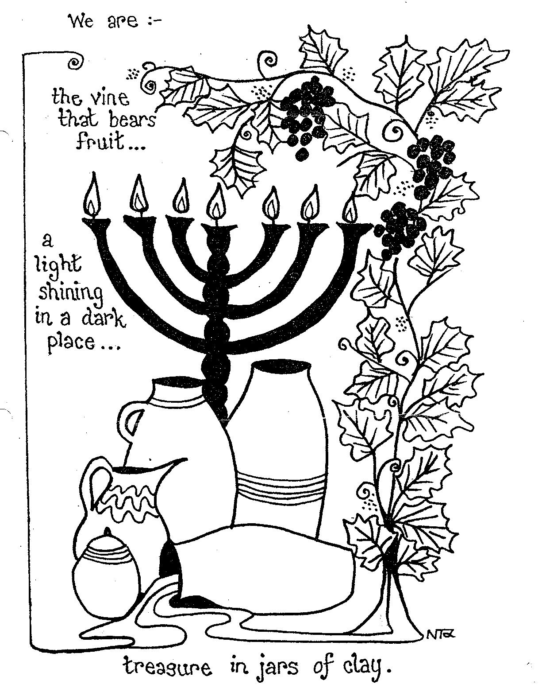

Hanukkah
pg

Host: There are many other lessons we can learn from the Maccabees as well. Their story is one cycle of a pattern we see repeated over and over throughout history.
Reader 7: Yah’s people begin to experience pressure to compromise with the prevailing culture around them, to stop keeping the Sabbath and the Feasts, and to stop reading and obeying the Torah.
Reader 8: Many fall away, but a remnant remains faithful to Yah and begins to experience escalating persecution, sometimes even to the point of death.
Reader 9: Then when it seems all hope is lost and Yah’s people will be no more, He intervenes miraculously and spectacularly on their behalf.
Reader 10: When we understand this pattern, we will not be surprised when we begin to experience pressure to conform and compromise, and we will be empowered to stand firm with the faithful ones who have gone before us, even in the face of grave persecution.
Reader 11: We will be able to trust that YHWH, who has been faithful time and again to deliver His people, will be faithful to us as well!
Reader 12: We learned during the Feast of Shavuot that YHWH has chosen us, the followers of Yeshua from every nation and tribe, to be His new Temple, the place where His Presence now dwells.
Reader 13: In light of that, the story of the Maccabees inspires us to rededicate ourselves to worshipping YHWH in purity and holiness.
Host: Let’s close our time together in prayer and then we can sing some more songs of thanksgiving and worship. YHWH our God, Ruler of the universe, who has chosen us among all peoples and sanctified us with Your love, we praise You!
Hostess: With an everlasting love, You have given us feasts, holidays, and both seasons and reasons for rejoicing.
Host: On this Feast of Dedication, Hanukkah, we celebrate the salvation and the freedom that You have given us, and we pray that You will strengthen us to remain faithful to You no matter what sorts of persecution come our way. May we be like lamps that are filled with the pure and never-ending oil of your Holy Spirit, shining the Light of Yeshua brightly into a dark world. Amen.

Suggested Songs: Songs for Children:
Our Flames Will Burn On by Tina Chen Give Me Oil in My Lamp
You Are Holy by Joshua Aaron This Little Light of Mine
Refiner’s Fire by Brian Doerksen
Goodness of God by CeCe Winans
Great is Thy Faithfulness by Thomas Chisholm
No Other Gods by Tim Timmons
Give Us Clean Hands by Chris Tomlin
Chanukkah by Marty Goetz
Feast of Dedication
Page 7
Script text written by Tina Chen © 2025
Image credit: https://practicalpages.wordpress.com/
Hanukkah
Host: Tonight is part of an important week, the eight-day Feast of Dedication, or Hanukkah, in which we celebrate a time in history that Yah miraculously preserved His people.
Hostess: Celebrating this Feast of Dedication together tonight links us with the past because it is an ancient tradition that has been handed down from generation to generation.
Reader 1: As a Jew living in the first century, Messiah Yeshua celebrated this feast with His family and friends, and by doing the same, we are following His example.
Reader 2: We celebrate today with the hope that the experience of Yah preserving, delivering, and cleansing will become part of our own personal experience.
Reader 3: A little more than 160 years before Messiah was born, a wicked king named Antiochus IV Epiphanes began to oppress Yah’s people, outlawing Sabbath observance and the keeping of Torah, and defiling Yah’s Temple by setting up an idol in it and sacrificing a pig on the altar.
Reader 4: Antiochus desired to either assimilate or obliterate Yah’s people, thereby eliminating any possibility of all the prophecies coming to pass about a Messianic king coming from Israel to rule the nations.
Reader 5: But Yah raised up a family of priests who refused to bend to Antiochus’ wicked demands.
Reader 6: Led by their father, Mattathias, and then by the third son Judah after the father’s death, their small band of warriors was able to defeat Antiochus’ large army and take back the Holy Temple in Jerusalem.
Reader 7: People gave Judah the nickname “Maccabee,” which means “hammer” in Hebrew, symbolizing his ferocity as a “hammerer” of Israel’s enemies.
Hostess: The name was later applied to his entire family and their supporters when they began to use it as a powerful battle cry, treating it as an acronym for the Hebrew phrase, “Mi Chamocha Ba’elim YHWH” which means “Who is like You among the gods, YHWH?”
Reader 8: While Hanukkah is not one of YHWH’s seven Appointed Times that we are commanded to observe in Leviticus 23, we learn from the book of John that it was a part of our Messiah’s culture and that He was in the Temple while this Feast was being observed.
Reader 9: We also learn from the books of Maccabees themselves that, in their minds, this feast they instituted was linked to Yah’s Appointed Feasts.
Reader 10: Two months ago, we celebrated the final Appointed Time of the year on Yah’s calendar, the Feast of Sukkot or Feast of Tabernacles, a time to gather and celebrate all of Yah’s goodness and faithfulness to us in the past, present, and future.
Reader 11: We learned that there are four components of Sukkot: sacrificial offerings to YHWH, dwelling in temporary shelters, days of rest with holy gatherings on the first and last days, and gathering fruit and branches to include in the joyful celebration.

Feast of Dedication
Reader 1: “This is the day that YHWH has made. We will rejoice and be glad in it!
Reader 2: “Hosanna! Save us now, we beg You, YHWH! YHWH, we beg You, send prosperity now.
Reader 3: “Blessed is he who comes in YHWH’s Name! We have blessed you out of YHWH’s house.
Reader 4: “YHWH is God, and He has given us light.
Reader 5: “You are my God, and I will give thanks to You. You are my God. I will exalt You.
Reader 6: “Oh give thanks to YHWH, for He is good,
All: “His loving kindness endures forever.”
Hostess: Let’s continue waving our fruit and branches while we sing a song about Yah’s loving kindness.

All Sing: Forever by Chris Tomlin
Verse 1 Give thanks to Yah, our God and King!
His love endures forever!
For He is good, He is above all things!
His love endures forever!
Sing praise, sing praise!

Verse 2 With a mighty hand and outstretched arm,
His love endures forever!
For the life that's been reborn,
His love endures forever!
Sing praise, sing praise!
Sing praise, sing praise!

Chorus Forever Yah is faithful!
Forever Yah is strong!
Forever Yah is with us!
Forever! Forever! (Forever!)

Verse 3 From the rising to the setting sun,
His love endures forever!
By the grace of Yah, we will carry on.
His love endures forever!
Sing praise, sing praise!
Sing praise, sing praise!
Page 1
Page 6

Reader 15: “Israel, trust in YHWH!
All: “He is their help and their shield.
Reader 16: “You who fear YHWH, trust in YHWH!
All: “He is their help and their shield.
Reader 1: “YHWH remembers us. He will bless us. He will bless the house of Israel.
Reader 2: “He will bless those who fear YHWH, both small and great.
All: “Blessed are you by YHWH, who made heaven and earth.
Reader 3: “I love YHWH, because He listens to my voice, and my cries for mercy. Because He has turned his ear to me, therefore I will call on Him as long as I live.
Reader 4: “YHWH is gracious and righteous. Yes, our God is merciful. YHWH preserves the simple. I was brought low, and He saved me.
Reader 5: “Return to your rest, my soul, for YHWH has dealt bountifully with you.
Reader 6: “What will I give to YHWH for all His benefits toward me? I will take the cup of salvation, and call on YHWH’s name.
Reader 7: “YHWH, truly I am Your servant. You have freed me from my chains.
Reader 8: “I will offer to You the sacrifice of thanksgiving and will call on YHWH’s name.
All: “Praise Yah!”
Reader 9: “Praise YHWH, all you nations! Extol him, all you peoples!
Reader 10: “For His loving kindness is great toward us. YHWH’s faithfulness endures forever.
All: “Praise Yah!”
Reader 11: “Out of my distress, I called on Yah. Yah answered me with freedom.
Reader 12: “YHWH is on my side. I will not be afraid. What can man do to me?
Reader 13: “It is better to take refuge in YHWH, than to put confidence in man. It is better to take refuge in YHWH, than to put confidence in princes.
Reader 14: “Yah is my strength and song. He has become my salvation. The voice of rejoicing and salvation is in the tents of the righteous.
Reader 15: “I will give thanks to You, for You have answered me and have become my salvation.
Reader 16: “The stone which the builders rejected has become the cornerstone. This is YHWH’s doing. It is marvelous in our eyes.

Reader 12: But in the year 164 BC, when the Maccabees were fighting to recapture the Temple in Jerusalem from the Greeks, they were unable to do so in time to be able to celebrate Sukkot properly and make all the offerings prescribed for that feast in Numbers 29.
Reader 13: When they finally did recapture the Temple, it had been grossly defiled, and both the Temple and the priests needed to undergo the eight-day purification process described in Leviticus 8 and 9.
Reader 14: We read in 2 Maccabees 10:1-8: “Then Maccabaeus and those who were with him, the Lord leading them on, recovered the temple and the city.
Reader 15: “They pulled down the altars that had been built in the marketplace by the foreigners, and also the sacred enclosures.
Reader 16: “Having cleansed the sanctuary, they made another altar of sacrifice.
Reader 1: “Striking flint and starting a fire, they offered sacrifices after they had ceased for two years, burned incense, lit lamps, and set out the show bread.
Reader 2: “When they had done these things, they fell prostrate and implored the Lord that they might fall no more into such evils; but that, if they ever did sin, they might be chastened by Him with forbearance, and not be delivered to blaspheming and barbarous heathen.
Reader 3: “Now on the same day that the sanctuary was profaned by foreigners, upon that very day it came to pass that the sanctuary was cleansed, even on the twenty-fifth day of the same month, which is Chislev.
Reader 4: “They observed eight days with gladness in the manner of the Feast of Tabernacles, remembering how, not long before, during the Feast of Tabernacles, they were wandering in the mountains and in the caves like wild animals.
Reader 5: “Therefore carrying wands wreathed with leaves, and beautiful branches, and palm fronds also, they offered up hymns of thanksgiving to Him who had successfully brought to pass the cleansing of His own place.
Reader 6: “They ordained also with a public statute and decree, for all the nation of the Jews, that they should observe these days every year.”
Reader 7: In the Jewish Talmud, we find the well-known legend most associated with Hanukkah about how there was only enough consecrated oil to burn for one day, but Yah miraculously made it last for eight days until more oil could be purified for Temple use.
Hostess: Whether or not the miracle of the oil really happened, the Hebrew phrase most closely associated with Hanukkah: “Neis gadol haya sham,” which means “A great miracle happened there” is nonetheless true. The Maccabees’ victory was truly a miracle — one they were determined to commemorate and make sure YHWH received glory for performing. As we light tonight’s candles in our hanukkiah, we join them in remembering and giving Yah glory for these miracles!
(Light the candles for the night you are celebrating.)
Page 2
Page 5
Hanukkah
Feast of Dedication

Reader 4: Too often we think of missed opportunities as permanent, or we’re so afraid of getting things wrong that we decide not to try at all.
Reader 5: In celebrating a “second Sukkot” two months after the festival ended, the Maccabees and their followers teach us that it’s never too late for a second chance and that YHWH looks at our hearts and honors our intentions and our best attempts to do things His way.
Reader 6: Rather than mourning a missed festival, their recent experiences of seeing YHWH’s power on display on their behalf led them to celebrate that missed opportunity with more passion than they probably would have the first time around.
Reader 7: Perhaps the Maccabees took their cue from Hezekiah’s delayed Passover observance in 2 Chronicles 30, where He prayed, “May the good YHWH pardon everyone who sets his heart to seek God, YHWH, the God of his fathers, even if they aren’t clean according to the purification of the sanctuary.”
Reader 8: We are told that YHWH listened to this prayer of Hezekiah’s and healed the people.
Reader 9: How much more can we trust the intercession of our good and tenderhearted King Yeshua, who also serves as our perfect High Priest, to cover us in our mistakes, impurities, and missed opportunities!
Reader 10: As we celebrate Hanukkah this year, let’s learn from the Maccabees by making the most of every opportunity and by creating a second chance for those times in which we can’t or didn’t.
Host: Let’s also take advantage of this second chance to do once again what we did at Sukkot — in the words we just read from the Maccabees, to carry “beautiful branches, and palm fronds also…. [and to offer] up hymns of thanksgiving to Him who successfully brought to pass the cleansing of His own place.”
Hostess: Please take a branch or some fruit and wave it as we read and sing some excerpts from Psalms 113-118 that we read at Sukkot.
(Everyone grab some branches and/or fruit.)
Host: “Praise Yah! Praise, you servants of YHWH, praise YHWH’s name. Blessed be YHWH’s name, from this time forward and forever more.
Reader 11: “From the rising of the sun to its going down, YHWH’s name is to be praised. YHWH is high above all nations, His glory above the heavens.
Reader 12: “Who is like YHWH, our God, who has His seat on high, who stoops down to see in heaven and in the earth?
Reader 13: “He raises up the poor out of the dust, lifts up the needy from the ash heap, that He may set him with princes, even with the princes of his people.
All: “Praise Yah!”
Reader 14: “Not to us, YHWH, not to us, but to Your Name give glory, for Your loving kindness, and for Your truth’s sake.

Host: It seems from the account we just read and from the letters preserved in the second book of Maccabees that they decided to follow the eight days of purification and dedication with a delayed celebration of Sukkot, beginning on the anniversary of the Temple’s defilement. They also invited those in the diaspora in Egypt to join them in commemorating those eight days and praising Yah for saving His people and restoring to them the Temple, the Priesthood, and the Kingdom. Here are excerpts from the letter they sent, preserved for us in the first chapter of 2 Maccabees:
Reader 8: “The kindred, the Jews who are in Jerusalem and those who are in the country of Judea, send greetings and good peace to the kindred, the Jews who are throughout Egypt.
Reader 9: “May God do good to you, and remember His covenant with Abraham, Isaac, and Jacob, His faithful servants, and give you all a heart to worship Him and do His will with a strong heart and a willing soul.
Reader 10: “May God open your heart to His law and His statutes, and make peace, and listen to your requests, and be reconciled with you, and not forsake you in an evil time….
Reader 11: “We prayed to the Lord and were heard. We offered sacrifices and meal offerings. We lit the lamps. We set out the show bread.
Reader 12: “Now see that you keep the days of the Feast of Tabernacles in the month Chislev….
Reader 13: “Having been saved by God out of great perils, as men arrayed against a king, we thank Him greatly. For He threw out into Persia those who fought against us in the holy city….
Reader 14: “Blessed be our God in all things, who handed over those who had committed impiety.
Reader 15: “Since we are now about to celebrate the purification of the temple in the month Chislev, on the twenty-fifth day, we thought it necessary to notify you, so that you may also keep a Feast of Tabernacles.”
Reader 16: The Maccabees and their followers missed the Festival of Sukkot because they were fighting, but when their battle was over, they went ahead and celebrated the festival, though the proper date for it had passed.
Reader 1: They understood that delayed obedience is better than disobedience. It was more important, a weightier matter, for them to come and meet with YHWH at His invitation even if they were late than it was for them to have all the details exactly right.
Reader 2: They didn’t want to wait another year to rejoice in His presence and to gather and celebrate His goodness and faithfulness, so they didn’t.
Reader 3: And they went even further by inviting all of Yah’s people to join them in their celebration, even those who were too far away to join in person!
Page 4
Page 3
Hanukkah
Feast of Dedication

