**Host:** Tonight is an important night, a night in which we celebrate a Biblical festival celebrated each year by Yah’s people — Yom Teruah, also known as the Feast of Trumpets!

**Hostess:** One of the unique things about this feast is that the Torah does not say what the purpose of this holy day is. Leviticus 23:24 simply says, “Speak to the children of Israel, saying, ‘In the seventh month, on the first day of the month, there shall be a solemn rest for you, a holy convocation, a memorial of *teruah,*” which is defined as a shout or blast of war, alarm, or joy.

**Reader 1:** The Torah gives at least one reason for all the other feasts and two reasons for some. Passover and The Feast of Unleavened Bread commemorate the Exodus from Egypt, and they are also a celebration of the beginning of the barley harvest.

**Reader 2:** The Feast of Pentecost, or Shavuot, is a celebration of the wheat harvest and traditionally a celebration of YHWH giving the Torah on Mt. Sinai.

**Reader 3:** The Day of Atonement next week, Yom Kippur, is a national day of atonement described in great detail.

**Reader 4:** And Sukkot or the Feast of Tabernacles that we’ll be celebrating in a couple weeks commemorates the wandering of the Israelites in the desert and is also a celebration of the ingathering of agricultural produce in the fall.

**Reader 5:** In contrast to all these Torah festivals, Yom Teruah has no clear stated purpose. We are only commanded to rest, to worship together, and to “*teruah.*”

**Reader 6:** Nevertheless, the Hebrew name of this feast, Yom Teruah, does provide a clue as to its purpose. Teruah literally means to make a loud noise. This word can describe the noise made by a trumpet, but it also describes the noise made by a large gathering of people shouting in unison.

**Reader 7:** A good example of this is in Joshua 6:5 when the Israelites were given their instructions for marching on Jericho,

**Reader 8:** “It shall be that when they make a long blast with the ram’s horn, and when you hear the sound of the shofar, all the people shall **shout** with a great **shout**; then the city wall will fall down flat, and the people shall go up, every man straight in front of him.”

**Reader 9:** In this verse the word “shout” appears twice, once as the verb form of *teruah* and a second time as the noun form of teruah. Although this verse mentions the sound of the shofar, the two instances of *teruah* do not refer to it. In fact, in this verse, *teruah* refers to the shouting of the Israelites which was followed by the fall of the walls of Jericho.

**Reader 10:** So while the Torah does not explicitly tell us the purpose of Yom Teruah, its name may indicate that it is intended as a day of public prayer and worship in which the crowd of the faithful shouts the name of YHWH in unison. The verb form of *teruah* often refers in Scripture to the noise made by a gathering of the faithful calling out to the Almighty in unison.

1

# Yom Teruah

**Reader 11:** Psalm 47:1-2 “Oh clap your hands, all you nations. Shout (*teruah)* to God with the voice of triumph!

**Reader 12:** For YHWH Most High is awesome. He is a great King over all the earth.”

**Reader 13:** Psalm 66:1-2 “Make a joyful shout *(teruah)* to God, all the earth!

**Reader 14:** Sing to the glory of his name! Offer glory and praise!”

**Reader 15:** Psalm 81:1-4 **“**Sing aloud to God, our strength! Make a joyful shout *(teruah)* to the God of Jacob!

**Reader 16:** Raise a song, and bring here the tambourine, the pleasant lyre with the harp.

**Reader 1:** Blow the shofar at the New Moon, at the full moon, on our feast day. For it is a statute for Israel, an ordinance of the God of Jacob.”

**Reader 2:** Psalm 100 “Shout *(teruah)* for joy to YHWH, all you lands!

**Reader 3:** Serve YHWH with gladness. Come before his presence with singing.

**Reader 4:** Know that YHWH, he is God. It is he who has made us, and we are his.

**Reader 5:** We are his people, and the sheep of his pasture. Enter into his gates with thanksgiving, and into his courts with praise.

**Reader 6:** Give thanks to him, and bless his name. For YHWH is good. His loving kindness endures forever, his faithfulness to all generations.

**Host**: With this in mind, we’ve chosen several songs to sing tonight in which we shout/sing out YHWH’s name together. Of course, a central observance of this holy day has for centuries also been the sounding of trumpets and the shofar, which heralds YHWH as King of the Universe.

**Reader 7:** We just heard from Psalm 81 that the blowing of the shofar was a part of every feast day, and Numbers 10:10 includes the command that silver trumpets be blown as well during the appointed feasts.

**Reader 8**: Trumpets and shofars are instruments of great spiritual significance. Their purposes include waking YHWH’s people out of their spiritual slumber, causing them to see the signs of the times, and reminding them to examine the spiritual condition of their lives.

**Hostess:** One of our favorite parts of celebrating the feasts is noting how they point so perfectly to Yeshua our Messiah. The spring feasts of Passover, Unleavened Bread, Firstfruits, and Pentecost are celebrated with great joy as already being fulfilled by Yeshua, but we still await His fulfilling of the fall feasts.

**Reader 9:** Today, we look forward to the day when the Lord Himself will descend from heaven with a shout, the final trumpet will sound, and we will be gathered to be with Him forever!

2

# The Feast of Trumpets

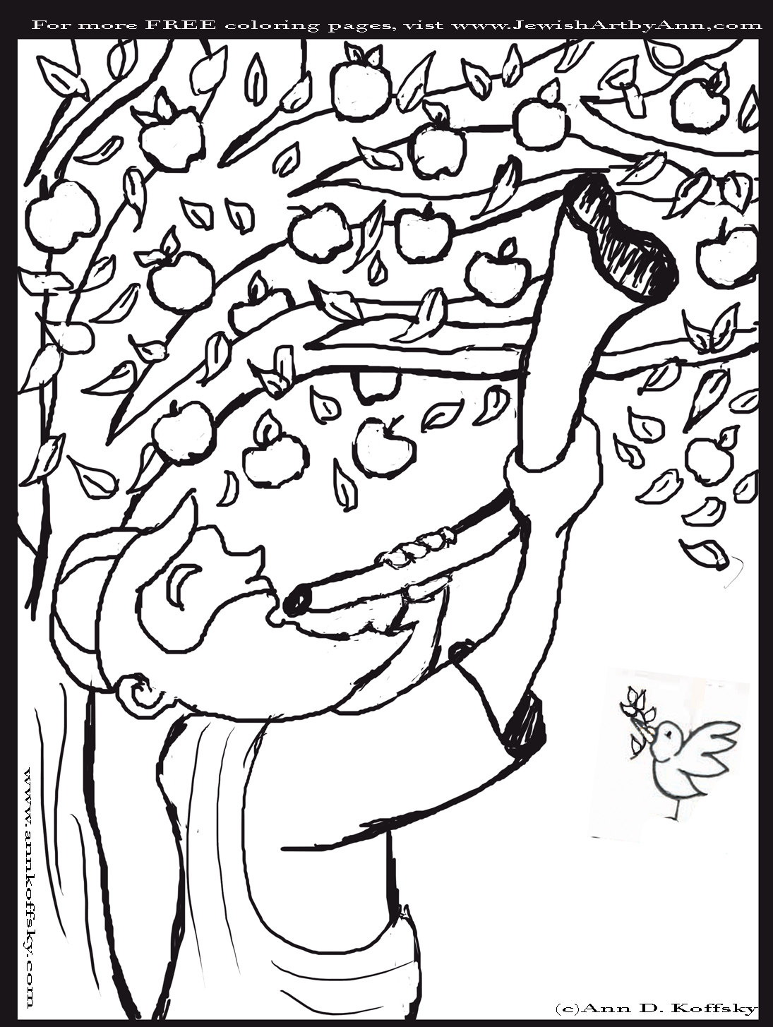

**Reader 10:** When Yeshua said that “no one knows of that day or hour” but the Father, He was making use of a well-known idiom of His day for this Feast of Yom Teruah, demonstrating the uncertainty around when it would begin each year.

**Reader 11:** Because it happens on the first day of the seventh month, watchers were always on the lookout at the end of the sixth month for the first glimpse of the new moon’s crescent so they would know when the feast began.

**Reader 12:** Everyone waited with great anticipation to hear the sound of the shofar that would announce that the new moon had been seen and the feast had begun.

**Reader 13:** In the same way, we wait with great anticipation to hear the sound of the trumpet of God at our Messiah’s return.

**Reader 14:** We may not know the day or the hour, but we do know the season, and He told us in Matthew 24 to watch the signs and know that He is near, even at the doors!

**Reader 15:** He also said in Revelation 22, “Yes, I am coming soon.” So we join with the many who have gone before us and say,

**ALL:** Amen! Yes, come, Lord Yeshua!

**Reader 16:** We are living in “such a time as this,” a time to carry out His presence and to be "human shofars” — to be a voice of one calling: "Prepare the way of YHWH in the wilderness! Make a level highway in the desert for our God. (Isaiah 40:3)

**Host:** As we celebrate this Yom Teruah, let’s each consider what kind of “voice” we are displaying to others through our lives. Let’s make our lives be the kind of “*teruah*” that will bring others to come to know our Messiah, to experience His kindness and mercy, and to know the power of His Set Apart Spirit to overcome the world!

**Hostess:** In Psalm 89:15, we are told that the people who know the *teruah* are blessed and that they walk in the light of YHWH’s presence. So with that in mind, let’s worship, proclaim His Name, and blow the shofars and the trumpets! Happy Yom Teruah!

**Songs**:

At Your Name by Phil Wickham

Your Name is our Favorite Word by Tina Chen

The Solid Rock by Edward Mote

HalleluYah by Tina Chen

Days of Elijah by Robin Mark

3

# The Feast of Trumpets

Yom Teruah