**Host:** Today is an important and solemn occasion, a day in which we observe a Biblical appointed time commemorated each year by Yah’s people — Yom Kippur, also known as the Day of Atonement.

**Hostess:** While the first two spring feasts have a triumphant and joyful tone to them as they recall Yah’s astounding acts of redemption, the first two fall feasts are much more subdued, full of religious rituals that demonstrate Yah’s holiness and justice.

**Reader 1:** Yom Teruah, which we celebrated ten days ago, was a time of sounding the alarm for Yah’s people to wake up, turn back to Yah, and follow His instructions in light of the imminent return of Messiah.

**Reader 2:** Yom Kippur celebrates Yah’s presence among His people while highlighting the vast gulf between His holiness and the sinfulness of His people. It included atonement for the people in the scapegoat ceremony which was but a part of the Day of Atonement’s rituals.

**Reader 3:** Leviticus 16:29-30 makes it clear that all who chose to follow YHWH, including Gentiles, were to participate in this holy day and that it was to be a permanent statute for all of Yah’s people.

**Reader 4: “It shall be a statute to you forever: in the seventh month, on the tenth day of the month, you shall afflict your souls, and shall do no kind of work, whether native-born or a stranger who lives as a foreigner among you;**

**Reader 5: “for on this day shall atonement be made for you, to cleanse you. You shall be clean from all your sins before YHWH.**

**Reader 6:** The word “atonement” means to purify or cleanse something that has sin or impurity. It actually comes from the Middle English phrase, “at one-ment,” denoting the goal of unity or reconciliation between Yah and the people He created, which is a major theme of the entire Bible.

**Reader 7:** Leviticus 16 is full of instructions on what the High Priest was required to do on this day, but interestingly, the people were literally required to do nothing on Yom Kippur. All they were asked to do was to afflict or humble themselves, cease from all labor, and wait in faith for the High Priest to do what was necessary for their atonement.

**Reader 8:** Even the other priests had to simply wait while the High Priest went into the Holy of Holies alone and offered atonement for the entire congregation.

**Reader 9:** This day is not about us and what we can offer to Yah. There weren’t even any sacrifices individuals could bring on this day.

**Reader 10:** Yom Kippur is all about realizing that there is nothing we can bring or do to atone for our own sin, and we are completely dependent on a High Priest to make atonement for us in a manner that Yah will accept.

1

# Yom Kippur

**Host:** The Hebrew word *anah* is the word commonly translated “afflict” in the Yom Kippur commands. In other places in Scripture, it is translated as “humble” or “humiliate.” It is often done to someone, but people can voluntarily do it to themselves as well, as is expected of us at Yom Kippur.

**Hostess:** The word *anah* in Scripture indicates a humble response to authority (whether voluntary or forced) and is often correlated with following Yah’s instructions. Listen to how it is used in the following verses:

**Reader 11:** Genesis 18:27 **“Abraham answered *(anah),* “See now, I have taken it on myself to speak to the Lord, although I am dust and ashes.”**

**Reader 12:** Exodus 10:3 **“Moses and Aaron went in to Pharaoh, and said to him, “This is what YHWH, the God of the Hebrews, says: ‘How long will you refuse to humble *(anah)* yourself before me? Let my people go, that they may serve me.”**

**Reader 13:** Psalm 119:71 **“It is good for me that I have been afflicted *(anah)*, that I may learn your statutes.”**

**Reader 14:** Psalm 119:75 **“YHWH, I know that your judgments are righteous, that in faithfulness you have afflicted *(anah)* me.**

**Reader 15:** While the word *anah* is negative when it is imposed by one human on another, when we do it to ourselves, it is positive. It is willingly placing ourselves under the authority of our Creator.

**Reader 16:** Though Yom Kippur is usually thought of as a day of fasting, the Torah does not focus on, or really even mention, fasting as being a part of Yom Kippur.

**Reader 1:** Instead, Yom Kippur is a call to humble ourselves before Yah in obedience to Him. We are to cease work, meditate, and focus on His authority.

**Reader 2:** In the Yom Kippur instructions in Leviticus 23, while fasting is not mentioned, the humbling or afflicting we are commanded to do on this day is linked four times to resting — to a complete cessation of all labor.

**Reader 3:** It is only after we stop and cease all our busyness that we can then humble ourselves by meditating on His ways, doing serious introspection on where we are aligned with or not aligned with His Torah, and repent where we need to repent.

**Reader 4:** Obviously, there is nothing wrong with fasting during Yom Kippur. Fasting can be a helpful tool to humble ourselves because it reminds us of our own mortality, and thus, our need of a Saviour from our promised end of death.

**Reader 5:** But it’s important to keep that purpose of fasting at the forefront of our minds if we choose to fast on Yom Kippur.

**Reader 6:** We must be very careful not to allow ourselves to slip into the idea that our fasting is something we bring or offer to Yah on this day, as that negates the whole point of Yom Kippur as a reminder to us that there is nothing we can do or bring to atone for our own sin, and we are completely dependent on a High Priest to make atonement for us in a manner that Yah will accept.

2

# The Day of Atonement

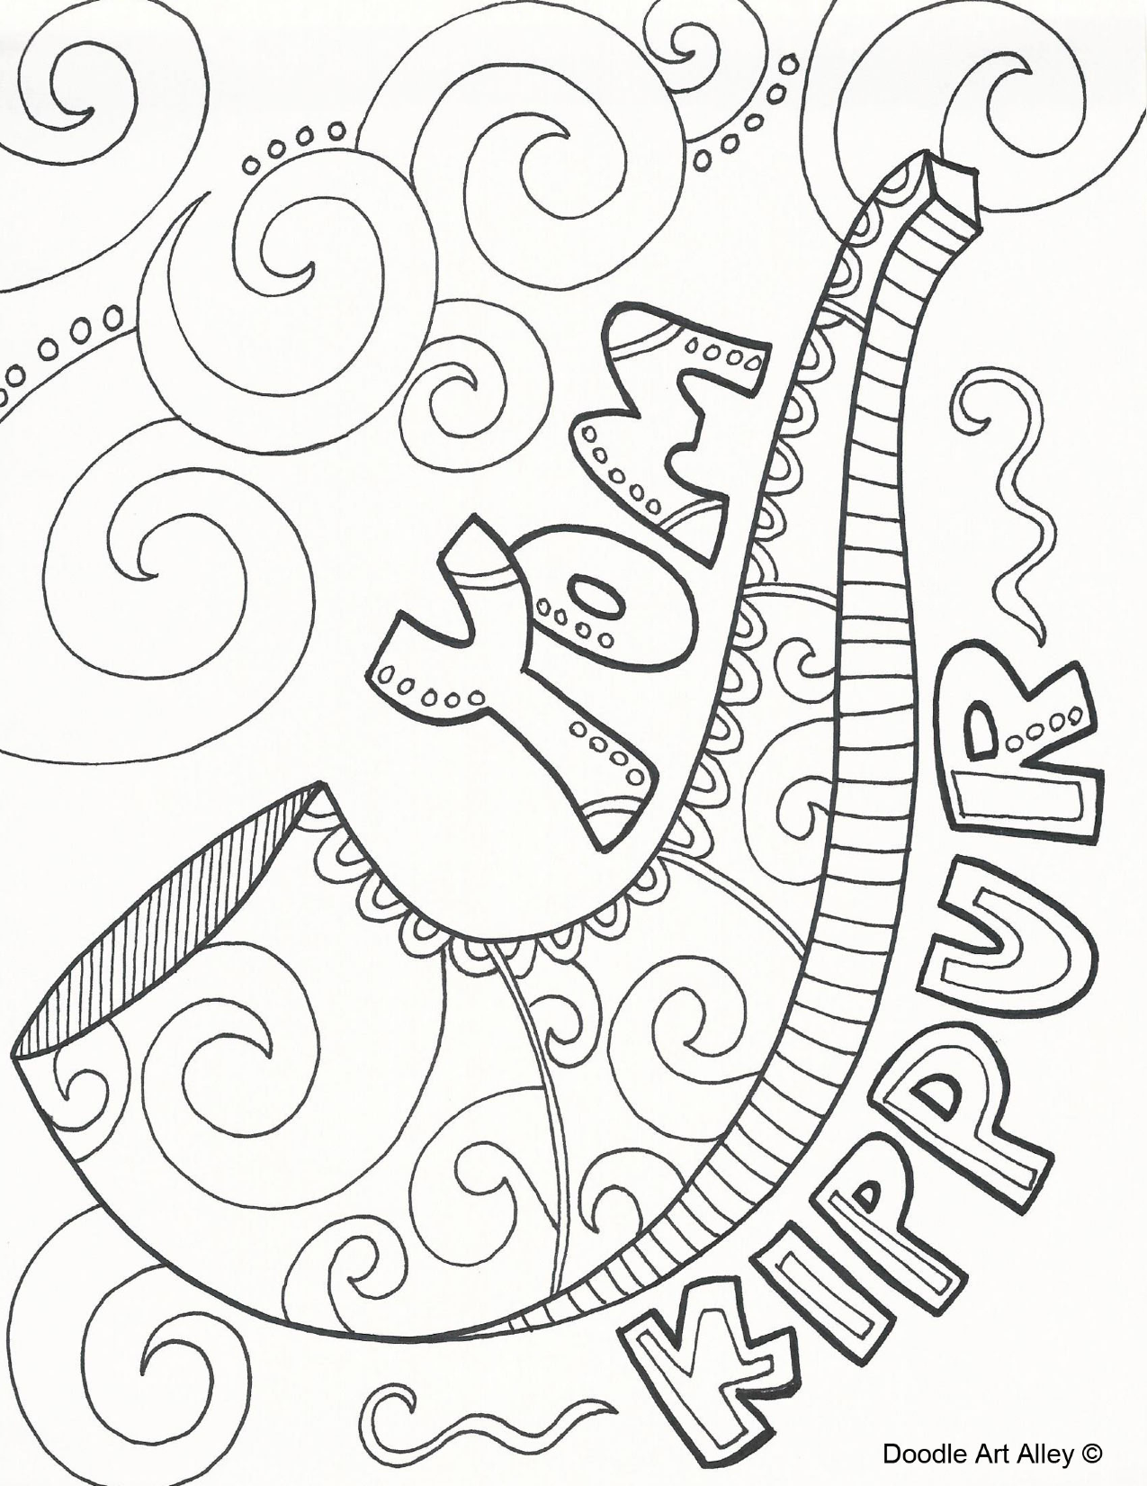

**Reader 7:** One who is wise and humble enough to really look at himself and see a need for a Saviour greater than himself is truly afflicting his soul in a manner consistent with Scripture.

**Reader 8:** While Yom Kippur truly was a somber day while the Temple was still in operation, it is interesting to note that Jewish writings say that there was no day more joyous each year than Yom Kippur because, as the High Priest exited the Holy of Holies, they knew the atonement was complete for the year. They could rejoice knowing that they were forgiven and free!

**Reader 9:** We, who recognize Yeshua as the promised Messiah, have even more reason to rejoice!

**Reader 10:** We know that He offered up his own body to be the perfect sacrifice for sin once for all time and that we can receive complete atonement before YHWH because of Yeshua’s shed blood.

**Reader 11:** Hebrews 9 tells us that Yeshua became our perfect and eternal High Priest who fulfills Yom Kippur in the heavenlies on our behalf.

**Reader 12: “But Messiah, having come as a High Priest of the coming good things, through the greater and more perfect Tabernacle not made with hands…nor yet through the blood of goats and calves, but through His own blood, entered in once for all into the Holy Place, having obtained eternal redemption.**

**Reader 13: “For Messiah hasn’t entered into Holy Places made with hands, which are representations of the true, but into heaven itself, now to appear in the presence of Yah for us;**

**Reader 14: “Nor yet that He should offer Himself often, as the High Priest enters into the Holy Place year by year with blood not his own, or else He must have suffered often since the foundation of the world.**

**Reader 15: “But now once, at the end of the ages, He has been revealed to put away sin by the sacrifice of Himself.**

**Reader 16: “Inasmuch as it is appointed for men to die once, and after this, judgment, so Messiah also, having been offered once to bear the sins of many, will appear a second time, without sin, to those who are eagerly waiting for Him for salvation.”**

**Host:** In light of all this, let us honor this holy day of Yom Kippur! Let us humble ourselves, cease from all labor, meditate on His ways, examine ourselves to make sure our lives are aligned with His Torah, and repent where we need to repent. Let us rejoice that our High Priest has already done all that is necessary for our atonement. And let us wait eagerly in faith for His return! As we said together on Yom Teruah, we cry again:

**ALL:** Amen! Yes, come, Lord Yeshua!

3

# The Day of Atonement

Yom Kippur